PRESS INFORMATION

Hagenberg, April 15, 2009

ubitronix Load Management Module: communication via narrowband PLC and long wave radio
Intelligent power management via programmable module

While in many places the introduction of a smart metering system and the required components is still being considered, ubitronix has closed an important gap with its introduction of the new LMM-2540 load management module. For the first time there is a solution available that can be wholly integrated in the existing smart metering infrastructure and individually programmed down to relay level. Via a bi-directional interface the load management module can be configured remotely and easily maintained. "This means that for the first time we are in the position to offer innovative services that go far beyond conventional ripple control technology", states Dr. Christoph Schaffer with satisfaction."

Conventional audio frequency ripple control technology is showing its age and has begun to cause many network providers much anxiety. Not only the non-existent flexibility with regard to operation, rather also the uncertainty regarding the states of the receivers is causing an increasing number of network providers to start thinking about replacements for existing ripple control technology. Power outages and the growing increase in energy consumption require intelligent demand-side management solutions in many places in order to manage electricity demand of customers and to optimize energy supply – requirements that are now being considered for the development of the load management modules by ubitronix.

Communication via narrowband power line
The new load management module achieves optimal performance with the NES infrastructure by Echelon, whose sales partner is ubitronix. In this combination, the existing narrowband power line infrastructure provided by the smart metering system is used in order to establish bi-directional data communication between the smart metering control centre and the load management modules. Thus not only the individual programming of the switching programs can be done in the field, event messages can also be sent to the modules. This makes it possible, for example, to turn lighting systems on or off based on a measured brightness value. The data of the entire functionality of the module (firmware update) can also be remotely configured and centrally controlled. This means the system can be adjusted to suit new requirements and the functionality always stays updated.
New with long wave radio ripple control as well
Via a partnership with the system provider EFR (Europäische Funkrundsteuerung – energy management via radio), ubitronix additionally expands its solution with long wave radio ripple control. This makes it possible for the first time worldwide, to link the advantages of long wave radio and narrowband power line communication within a smart metering infrastructure. Using radio ripple control via long wave radio, all load management modules used in the system can be provided with information simultaneously and within a few seconds. The specific function triggered by a message - transmitted via long wave - using an unambiguous address and based on the individual programming facility via narrowband power line, can be defined individually for each load management module or for each device group. This means that not only conventional load management scenarios can be realised, but also rate-dependent circuits can be realised in real-time. "The advantage of this solution on the one hand, is that the load management modules can be addressed parallel almost in real-time and, on the other hand, in the individual programmability. This makes it possible for the first time to realise intelligent load management scenarios, such as, e.g., load shedding or rate-dependent switch-overs", explains Schaffer.

Flexible control and monitoring
The load management modules can be individually equipped with up to four 25 A or 40 A relays such that these devices can immediately replace existing ripple control devices. An integrated real-time clock guarantees self-sufficient operation, for example, as a switch clock. In combination with the integrated astronomical calendar, street lighting can be controlled, independent of communicating with the control centre. A voltage monitoring function facilitates intelligent reloading in case of an electrical outage – cold hot water tanks thus become a thing of the past. Furthermore, not only are all events recorded in the device, but in the case of manipulation or failure, the control centre is informed immediately and automatically, ensuring a high degree of operational dependability. The load management device currently has a M-bus interface and can thus be operated with almost any smart metering system.
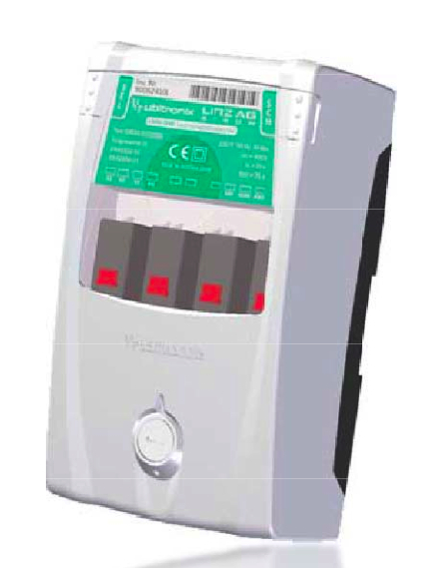

Image caption: Load management module LMM_2540 by ubitronix

A high-resolution photo is available for download here: www.press-n-relations.com

Further information:  ubitronix system solutions GmbH - Dr. Christoph Schaffer  Softwarepark 35/2 - A-4232 Hagenberg, Austria  Tel.: +43 7236 3343 310 - Fax: +43 7236 3343 312  christoph.schaffer@ubitronix.com - www.ubitronix.com | Press and publicity:  Press'n'Relations GmbH Vienna office – Barbara Hinger  Schwindgasse 10 - A-1040 Vienna, Austria  Tel.: +43 1 907 61 48-11 – Fax: +43 1 907 61 48-15  bhi@press-n-relations.at – www.press-n-relations.com

ubitronix system solutions GmbH was founded in 2004 in Hagenberg (Upper Austria) and develops energy management solutions. With Unified Intelligent Energy Management (Unified IEM), ubitronix supports both energy provider as well as network providers to handle growing demands of the liberalised energy market. Alongside automated management for electricity, gas, water and heat meters, load management, house and building automation, voltage quality monitoring and control of street lighting are also covered integratively within a system solution. As part of its range of modern, expandable solutions, ubitronix offers a series of communication, readout and voltage management products that are marketed worldwide and can be seamlessly integrated into the Networked Energy Services (NES) System of Echelon. Metering technologies of other manufacturers can be easily integrated as well.

